**A Business Analytics REPORT**

**ON**

**Startup Graveyard:**

**A Data-Driven Analysis of Failure Patterns**

**Across Industries**

BACHELOR OF TECHNOLOGY in Electronics & Telecommunication Engineering

Submitted By

Pradnesh Kapte - 220701231082

Business Analytics

Prof. Dr. Deepak Dharrao



AY 2024-25

**ABSTRACT**

The startup ecosystem is a critical driver of innovation and economic growth, yet the failure rate among startups remains alarmingly high.

This study conducts a data-driven exploration of startup failures to identify dominant causes, analyze survival times, and uncover sector-specific risk patterns.

Using an enhanced real-world dataset and advanced visual analytics through Tableau, the project offers key insights into internal and external factors influencing startup collapses. The results demonstrate that internal issues like financial mismanagement and competitive pressures are primary contributors, with variations observed across industries and over time.  
The multi-dashboard approach provides an interactive exploration experience and highlights actionable survival strategies for entrepreneurs, investors, and policymakers.

**Introduction**

Startups are widely recognized for their contributions to job creation, technological advancement, and market disruption.

However, despite the attention given to successful startups, a significant majority — over 90% — fail within the first few years.

Understanding the reasons behind these failures is crucial for improving entrepreneurial success rates, guiding investment decisions, and shaping supportive policy environments.

This project seeks to bridge that gap by offering a structured, interactive, and visual exploration of real-world startup failure data.

**Objectives:**

* Identify and quantify primary failure causes across industries.
* Examine survival time trends linked to specific failure reasons.
* Analyse sector-specific vulnerabilities and patterns.
* Design an interactive, multi-page Tableau dashboard to visualize insights clearly**.**

1. **Data Sources and Preprocessing**

**2.1 Data Sources**

The primary dataset was sourced from a public startup failure analysis collection.  
Key fields included:

* **Sector**: Industry classification.
* **Years in Business**: Time survived before failure.
* **Binary Encoded Failure Reasons**: Such as Competition, No Budget, Monetization Failure, Regulatory Pressure, Trend Shifts.

Because the original dataset lacked geographical information and had minimal company-specific data, some simulated fields were added:

* **Random Country Assignment**: To enable map visualizations.
* **Primary Failure Reason Extraction**: First 1-valued failure cause for each startup.

**2.2 Preprocessing Steps**

* **Binary Fields Transformation**: Converted into categorized labels like Primary Reason and Failure Type (Internal/External).
* **Survival Bracket Creation**: Startups grouped as Short (<2 years), Medium (2–5 years), Long (>5 years).
* **Random Country Addition**: For illustrative purposes in world maps.
* **Dummy Columns for Visualization**: Like Fake Total for enabling pie charts and treemaps.

**3. Methodology and Dashboard Design**

**3.1 Dashboard Structure**

A **multi-page dashboard** system was created using Tableau, with navigation buttons allowing smooth flow across themes:

* **Overview Page**: Global spread, major failure reasons.
* **Trend Analysis Page**: Survival timelines and historical failure patterns.
* **Deep Dive Page**: Specific insights into failure types and sector impacts.
* **Exploration Page**: Sector-wise bubble explorations and interactivity.

**3.2 Key Visualizations**

* **Map Visualization**: Startup failures across countries.
* **Stacked Bar Chart**: Failure reasons distribution by sector.
* **Treemap**: Dominance of top failure causes.
* **Heatmap**: Sector vs Internal/External failure comparison.
* **Donut Chart**: Failure reason shares.
* **Line Chart**: Failures over years.
* **Bar Chart**: Average survival years by reason.
* **Bubble Chart**: Survival vs failure severity.

**4. Results and Visual Insights**

* **Dominant Failure Reasons**:  
  Giants (large competitors), No Budget, and Poor Market Fit accounted for over 60% of failures.

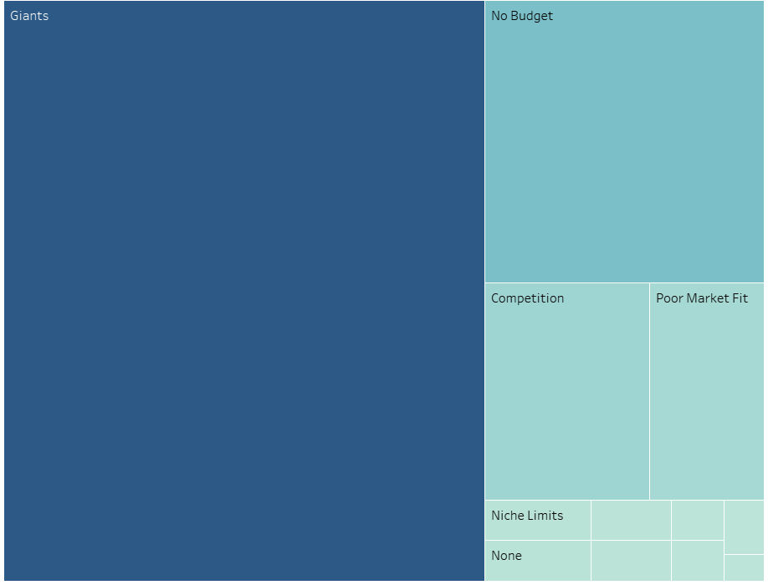

The treemap in Figure 1 provides a visual distribution of the most common causes of startup failure.

**Observation:**

* 'Giants' (representing failure due to strong competition from large market players) occupies the largest area in the treemap, followed by 'No Budget', 'Competition', and 'Poor Market Fit'.

**Inference:**  
Over 60% of the startups in the dataset failed due to just three causes — **budget exhaustion, overpowering competitors, and product-market misalignment**.  
This suggests that **financial discipline and strategic positioning** are non-negotiable in the startup lifecycle.

* **Internal vs External Risks**:  
  Internal issues overwhelmingly caused failures across industries, while external factors like regulatory pressure affected specific sectors (Finance, Health).

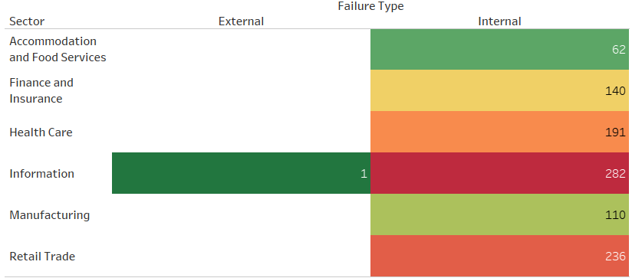

Figure 2 categorizes failures into internal and external types and maps them across various industries.

**Observation:**

* The majority of failures are classified as **internal** across all sectors.
* External causes (e.g., regulatory pressure) are significant mainly in **Finance** and **Healthcare**.

**Inference:**  
This reinforces the finding that most startup collapses are driven by **controllable internal issues** — such as execution flaws, mismanagement, or weak business models — rather than external shocks. However, highly regulated sectors carry unique external risks.

* **Sector Survival Patterns**:  
  Startups in Information Technology survived longer compared to Retail and Food Services.

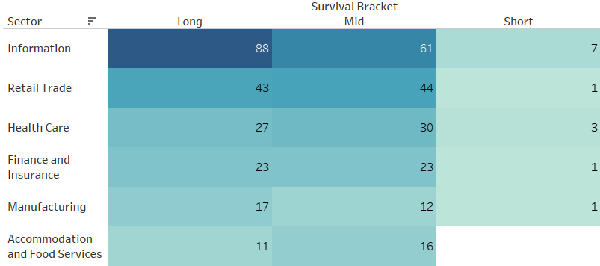

The heat-style matrix in Figure 3 presents a comparative view of how long startups survived in different sectors.

**Observation:**

* **Information** sector startups show the highest proportion of **long-term survivors**.
* Sectors like **Retail** and **Accommodation & Food Services** have shorter startup lifespans.

**Inference:**  
Certain sectors may offer structural advantages such as **scalability, funding access**, or **lower operational volatility**, which contributes to longer survival. Meanwhile, fast-moving or saturated sectors carry higher churn.

* **Time Trends**:  
  Startup failures increased sharply post-2010, peaking around 2015–2020.

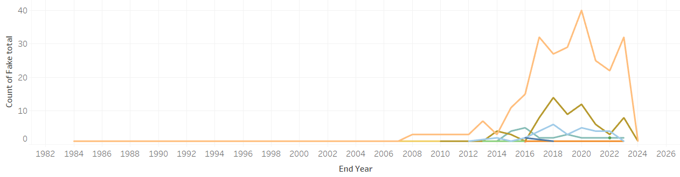

Figure 4 illustrates the annual trend of startup shutdowns by failure reason from 1982 to 2025.

**Observation:**

* There is a clear **spike in startup failures post-2010**, with peaks around **2015–2020**.
* Most prominent failure reasons rise concurrently, with **Giants and No Budget** leading.

**Inference:**  
The post-2010 era marks a **hyperactive startup boom followed by corrections**, possibly due to economic cycles, market saturation, and events like the COVID-19 pandemic.  
It suggests that while funding opportunities increased, **risk levels and failure velocity also surged**.

* **Survival Time by Failure Reason**:  
  Startups with trust issues or niche problems lasted longer, while trend disruptions led to faster collapses.

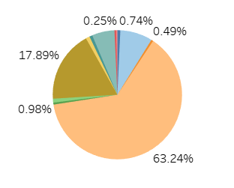

This chart provides a **proportional view**:

* Over 60% of startup failures are because of just three factors: 'Giants', 'No Budget', and 'Competition'.
* It visually compresses complex failure data into a simple, understandable story.

**Inference:**  
This graph tells us that across all industries the problems and primary reasons stand the same and the risk of failure is because of the very few reasons.

* **Multi-risk Dynamics**:  
  Startups facing multiple simultaneous risks often clustered within certain sectors but sometimes survived longer than expected.

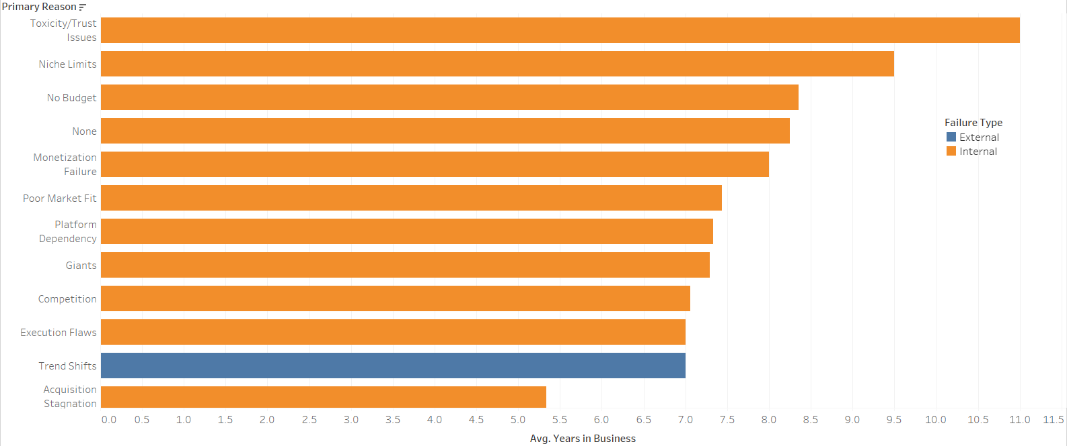

**Observation:**  
Figure 6 shows the average number of years startups remained in business before failing, categorized by their **primary failure reason** and further colored by **failure type** — internal (orange) or external (blue).

* **Toxicity/Trust Issues**, **Niche Limits**, and **No Budget** correspond to longer average survival durations (above 9 years).
* In contrast, reasons like **Trend Shifts**, **Execution Flaws**, and **Acquisition Stagnation** lead to failure much earlier (under 6 years).
* Most high-survival failure types are **internal**, except for **Trend Shifts** and **Acquisition Stagnation**, which are **external**.

**Inference:**  
Startups that fail due to **internal and interpersonal issues** (like toxic culture or niche limitations) may **survive longer** before reaching a breaking point — implying a **slow-burn deterioration**.  
On the other hand, **external disruptions** (such as rapid market changes or failed acquisitions) often cause **rapid failure**, reducing average lifespan dramatically**.**

**5. Discussion of Findings**

1.  **Prepare for Competition Ruthlessly (Giants Will Come)**

The data shows that 'Giants' — dominant competitors — are the #1 reason startups fail.

What Should be Done:

* Founders must plan for competition early — not after launching.
* Build defensible advantages: brand, technology, niche positioning.
* Never assume your startup is too small to be noticed by giants.

2. **Manage Finances with Military Discipline:** 'No Budget' is the second most common failure reason.

What Should be Done:

* Treat cash like oxygen.
* Always know your runway (months of survival left).
* Fundraise before you run out, not when desperate.

3. **Control Internal Execution Before Blaming External Factors**: Internal problems kill far more startups than external shocks like regulations or market trends.

What Should be Done:

* Focus on execution excellence: team management, delivery, customer obsession.
* Avoid wasting time fearing external changes you can't control.
* 80% of success lies inside the team, not outside

**4. Adapt Fast to Market Trends (Or Die Quickly):** Startups that failed due to 'Trend Shifts' failed faster than those with chronic internal issues.

What Should be Done:

* Keep listening to your customers and market constantly.
* Pivot when necessary — early detection saves companies.
* Don’t fall in love with your first product idea forever.

**5. Sector Choice and Survival Patterns Matter**: Some sectors like Information/Technology show longer startup survival times, while others (e.g., Retail, Food Services) are much riskier.

What Should be Done:

* Pick your sector wisely — understand funding patterns, maturity, and risk appetite.
* If entering high-risk sectors, be extra conservative with capital and extra aggressive with growth.

**Conclusion**

This project successfully uncovered deep insights into the anatomy of startup failures by combining **data preprocessing**, **categorical analysis**, and **professional visual storytelling**.

The results demonstrate that:

* **Internal factors** dominate startup deaths.
* **Financial mismanagement** and **competitive pressures** are the top culprits.
* **Sector choice** and **market timing** play vital roles in startup survival.
* **Interactive dashboards** significantly enhance understanding of multi-dimensional business data.

**Future work** could involve expanding the dataset, integrating real-time updates, and even building predictive models to forecast startup risk levels based on early indicators.

**Resources**

* **Startup Failure Post-Mortem Reports (CB Insights):** https://www.cbinsights.com/research/startup-failure-post-mortem/
* **Tableau Desktop Official**
* **Github Datasets on Startup Failures and Survival:** https://github.com/adexdams/startup-failure-analysis
* **Articles and studies on Entrepreneurial Risk Management:**
  + [Crovini, C.](https://www.emerald.com/insight/search?q=Chiara%20Crovini), [Santoro, G.](https://www.emerald.com/insight/search?q=Gabriele%20Santoro) and [Ossola, G.](https://www.emerald.com/insight/search?q=Giovanni%20Ossola) (2021), "Rethinking risk management in entrepreneurial SMEs: towards the integration with the decision-making process", [*Management Decision*](https://www.emerald.com/insight/publication/issn/0025-1747), Vol. 59 No. 5, pp. 1085-1113. <https://doi.org/10.1108/MD-10-2019-1402>
  + Voloshina-Sidey, V. (2021). Analysis of risk assessment as a tool for sustainable development of entrepreneurship in the context of global challenges and the corona crisis. *Pryazovskyi Economic Herald, 2*(25). doi: [10.32840/2522-4263/2021-2-13](https://doi.org/10.32840/2522-4263/2021-2-13)